GITAM

(DEEMED TO BE UNIVERSITY)

**TITLE**:PCB WORKSHOP

**SUB TITLE :** ANALOG AND DIGITAL

ECE DEPARTMENT

**TEAM MEMBERS** :

NAMES:

N.KEERTHI (BU21EECE0100410)

HIMA BINDU (BU21EECE0100087)

KANIKI CHAKRADHAR REDDY (BU21EECE0100170)

SAI JAYANTH (BU21EECE0100310)

**PCB WORKSHOP**

# **DIGITAL CIRCUIT:**

Simulation results for Low Pass Filter:

Components Required:

* Bread board
* Power supply
* Resistors
* Led
* AND Gate IC – 74HC08
* XOR Gate IC – 74HC86
* DIP Switch SPST X 4

## CIRCUIT DIAGRAM:

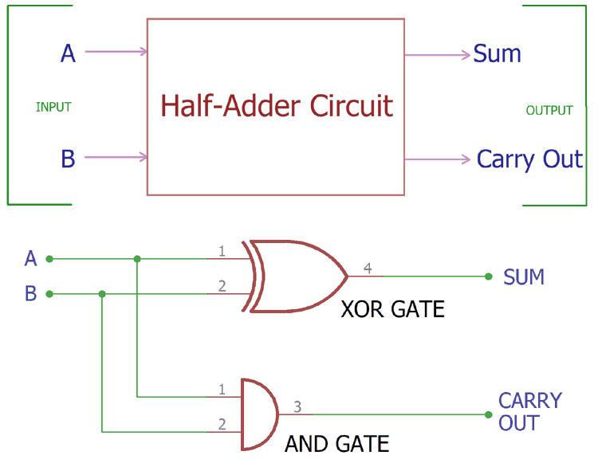

Procedure:

• **Place the Breadboard**: Drag and drop a breadboard onto the workspace.

• **Place the ICs**: Drag the 7408 (AND gate) and 7486 (XOR gate) ICs onto the breadboard, ensuring they are positioned across the central divider.

• **Connect Power and Ground**:

* Connect the VCC (pin 14) of both ICs to the positive power rail.
* Connect the GND (pin 7) of both ICs to the ground rail.

•**Setting up the DIP Switch SPST X 4**:

* Connect the 1A and 2A to the positive VCC.
* Connect the 1B and 2B are the common inputs for the gates.

• **Connecting the XOR Gate (7486) for the Sum**:

* Connect the first input of the XOR gate (pin 1) to the 1B (A input).
* Connect the second input of the XOR gate (pin 2) to the 2B (B input).
* The output of the XOR gate (pin 3) will be the Sum output.

• **Connecting the AND Gate (7408) for the Carry**:

* Connect the first input of the AND gate (pin 1) to the 1B (A input).
* Connect the second input of the AND gate (pin 2) to the 2B (B input).
* The output of the AND gate (pin 3) will be the Carry output.

• **Connecting LEDs**:

* Place two LEDs on the breadboard.
* Connect a 150 Ohm resistor to the anode (long leg) of each LED.
* Connect the resistor of the first LED to the Sum output (pin 3 of the XOR gate).
* Connect the resistor of the second LED to the Carry output (pin 3 of the AND gate).
* Connect the cathodes (short leg) of both LEDs to the ground rail.

# • **Final Connections**:

* Ensure all components are properly connected.
* Connect the power supply to the breadboard.

**Hardware Implementation:**

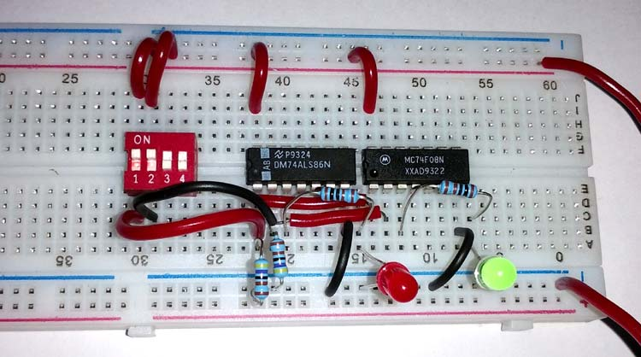

# **Circuit Schematic in TINKERCAD:**

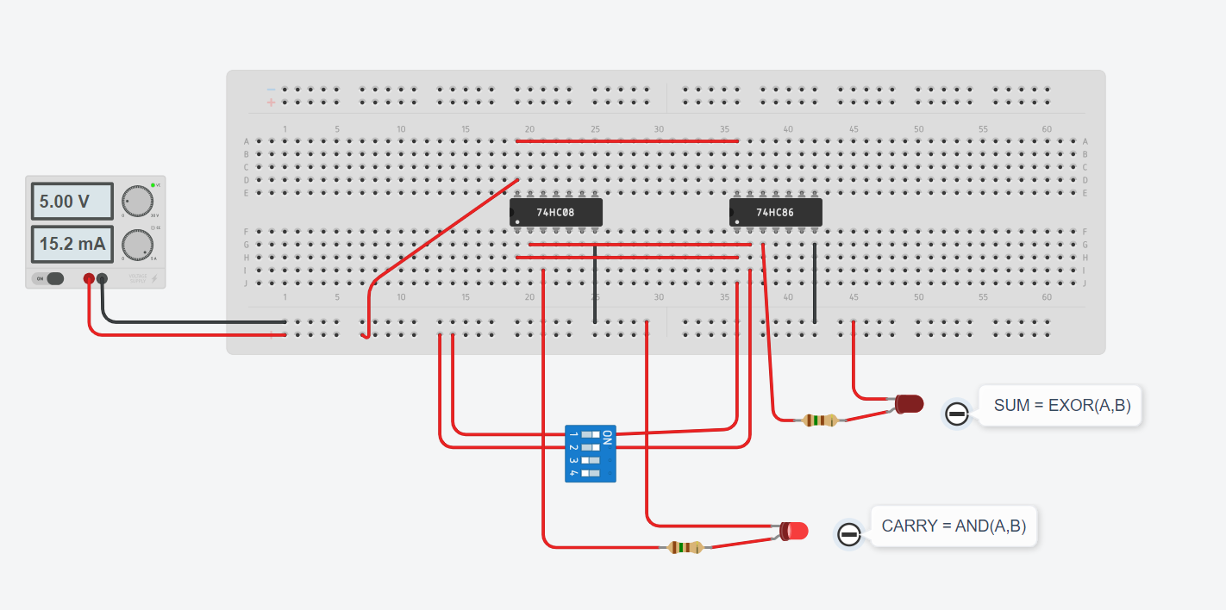

# **Simulation in Easy Eda:**

• **Create a New Project:**

* Open Easy EDA.
* Click on "New Project" and give it a name, like "Half Adder Design."

• **Add Components:**

* You need two logic gates: an XOR gate and an AND gate.
* In the components library, search for "XOR gate" and "AND gate."
* Drag and drop one XOR gate and one AND gate onto your schematic canvas.

• **Add Input and Output Ports:**

* You need two input ports (A and B) and two output ports (Sum and Carry).
* Search for "Input" in the components library and add two input ports.
* Search for "Output" in the components library and add two output ports.

• **Wire the Components:**

* Connect one input port (A) to one input of both the XOR gate and the AND gate.
* Connect the second input port (B) to the other input of both the XOR gate and the AND gate.
* Connect the output of the XOR gate to one output port labelled "Sum."
* Connect the output of the AND gate to the other output port labelled "Carry."

• **Label the Ports:**

* Right-click on each input and output port to rename them as A, B, Sum, and Carry.

• **Check and Save:**

* Check your connections to ensure everything is wired correctly.
* Save your schematic.

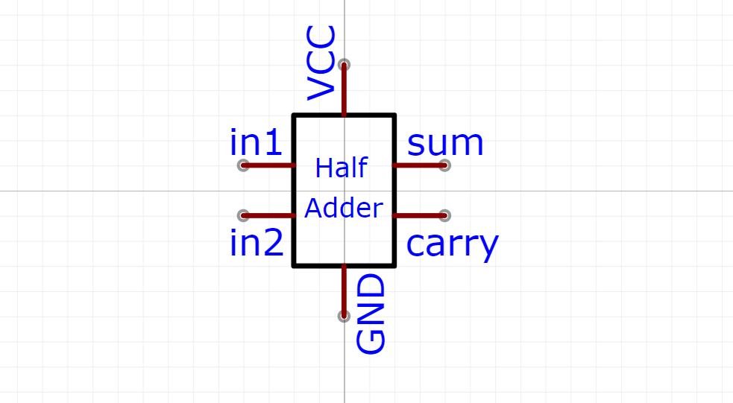

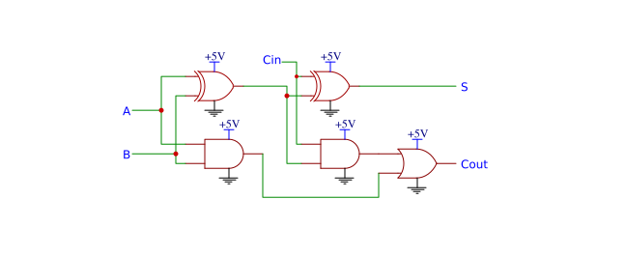

**Conclusion:**

To conclude the analysis of a half adder using Tinker cad and Easyeda, we can summarize the findings from both tools. The half adder is a fundamental digital circuit used to perform binary addition, consisting of two inputs (A and B) and two outputs (Sum and Carry). Here's a concise conclusion based on simulations and designs in both platforms: